STRATEGIC PRAYER FOCUS
Each of you in the group is to identify two or three whom you feel led to pray for their salvation. List the names of all those identified in the group on each card so that all of you pray for each of the lost souls weekly. We recommend that you keep this card in your Bible as a bookmark for your daily reading so that each time you open your Bible you are reminded to pray for these souls.
_____________________ _____________________
_____________________ _____________________
_____________________ _____________________

- Lord, I pray that you draw _____ to Yourself (John 6:44).
- I pray that _____ will seek to know You (Acts 17:27).
- I pray that _____ will hear and believe the Word of God for what it really is (1 Thess. 2:13).
- I ask You, Lord, to prevent Satan from blinding _____ to the truth (2 Cor. 4:4; 2 Tim. 2:25-26).
- Holy Spirit, I ask You to convince _____ of sin and the need for Christ’s redemption (John 16:7-14).
- I ask that You send someone who will share the gospel with _____ (Matt. 9:37-38).
- I also ask that You give me or _____ the opportunity, the courage and the right words to share with _____ (Col. 4:3-6).
- Lord, I pray that _____ will turn from sin and follow Christ (1 Thess. 1:9-10).
- Lord, I pray that _____ will put all of his/her trust in Christ (John 1:12; John 5:24).
- Lord, I pray that _____ will confess Christ as Lord, grow in faith and bear fruit for your glory (Rom. 10:9-10; Col. 2:6-7; Luke 8:15).

This brochure can be downloaded at hurstbournebc.org/makingdisciples.

Our church staff would be honored to pray for your LTG! If you would like us to pray for your group, send an email with your group members’ names to reception@hurstbournebc.org.

Adapted from Neil Cole’s Life Transformation Groups Cards ©1999. www.CMAResources.org. Used by permission. For more information about Neil Cole’s Life Transformation Group approach, see http://cmaresources.org/article/ltg, and see his books Cultivating a Life for God and Search and Rescue.

Scripture quotations are from The Holy Bible, English Standard Version, copyright ©2001 by Crossway Bibles, a publishing ministry of Good News Publishers. Used by permission. All rights reserved.

Hurstbourne Baptist Church
8800 Shelbyville Rd, Louisville KY 40222
(502) 426-2444
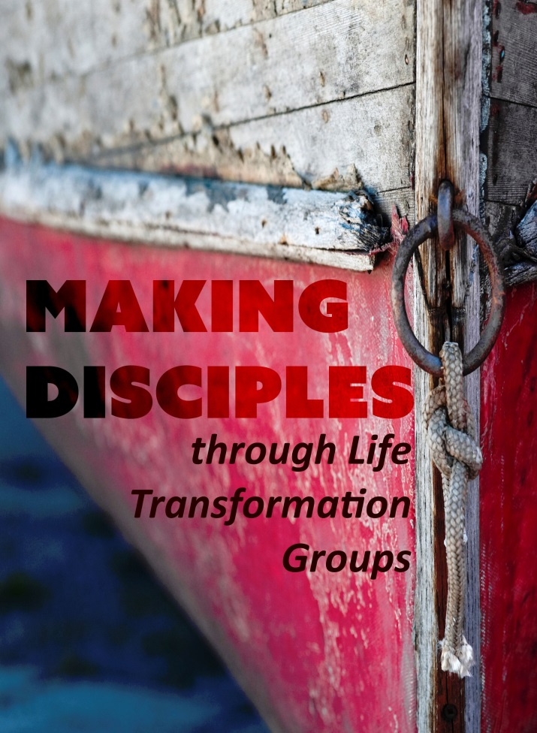
hurstbournebc.org

And Jesus said to them, “Follow me, and I will make you become fishers of men.”
Mark 1:17

WHAT IS A
LIFE TRANSFORMATION GROUP?
A Life Transformation Group (LTG) is a simple way to release the most essential elements of a vital spiritual walk to people who need Jesus to change their lives from the inside out. It is a grassroots tool for growth which encourages and supports people to follow Christ by fueling internal motivation rather than applying external pressures and ploys. This tool empowers the common Christian to accomplish the uncommon work of reproducing spiritual disciples who can in turn reproduce others.

Here is a simple overview of our LTGs:
- LTGs meet once a week for approximately an hour.
- LTGs are groups of two or three (the addition of a fourth person is the beginning of the second group and multiplication is imminent).
- The groups are not co-ed, but gender specific.
- LTGs recognize Jesus as their primary leader and the Bible as their primary authority.
- Only three tasks are to be accomplished in an LTG:
  - Sin is confessed in mutual accountability.
  - Scripture is read repetitively in context and in community.
  - Souls are prayed for strategically, specifically and continuously.
An LTG is simple, yet powerful. It incorporates the values of community, internal life transformation and reproduction of disciples.

WHO SHOULD BE IN AN LTG?
There are only two suggested qualifications for starting or joining an LTG:
- A desperate need for Jesus Christ
(Luke 5:29-32).
- Faithfulness in the process itself (2 Tim. 2:2).
These two criteria balance one another to keep the group on track both with healing for hurting people and health for helping people. To compromise either of these principles will slow down or derail the effectiveness of the group.

through Life Transformation Groups

An LTG is made up of two or three people, all of the same gender, who meet weekly for personal accountability for their spiritual growth and development. It is recommended that a group not grow past three but rather multiply into two groups of two once the fourth participant has proven faithful to the process.

WHY MEET IN SUCH A GROUP?

- Community: Life change does not occur in a vacuum; it happens in relationship with others. From the beginning God has said that it is not good to be alone. We need each other for strength and support (Eccl. 4:9-12, Prov. 27:17).
- Accountability: Few things would get done in life without some degree of accountability. The New Testament lists at least twenty eight “one another” commands. There’s no doubt we need one another to live the life Christ intends for us.
- Confidentiality: It is easier to maintain confidentiality in a group of only two or three rather than a larger group. And Jesus taught his disciples that sin should be addressed and confessed in as small a group as possible (Matt. 18:15-17).
- Flexibility: It is much easier to coordinate the calendars of only two or three rather than a typical small group. An LTG can meet anywhere!
- Reproducibility: It is easier to reproduce a smaller, simpler group than a larger and more complex entity. Perhaps that is why the Lord commanded us to make more disciples rather than cell groups or churches (Matt. 28:18-20). Transformed disciples in community are the base unit for the kingdom of God.
There are only three tasks to be accomplished in an LTG. They are. . .

- SIN IS CONFESSED IN MUTUAL ACCOUNTABILITY
Christians need one another (Hebrews 10:24-25). There is strength in relationships that are built around supporting one another. The first thing the LTG does together is ask each other Character Conversation Questions listed on the attached card. The meetings start here because it is easy to lose time talking about other things. It is also helpful to begin with the confession of sin which tends to sanctify the rest of the meeting. The questions are straightforward. Each person takes turns answering the same question. The group must be a safe place to be honest in. The confession of sin prepares the soil of people’s hearts for the Word of God being read each week.

- SCRIPTURE IS READ REPETITIVELY – IN CONTEXT AND IN COMMUNITY
The power of this system is in the unleashing of God’s Word in the lives of people. Jesus made it clear that the Word of God is the seed of new life (Luke 8:1-15). To expect lives to be changed and bear fruit without first planting the seed is foolish and disappointment will result.

Each group decides on a book of the Bible they will read that week. The goal is to create an internal appetite for the rich Word of God, so a larger volume of Scripture is desired. It is recommended that one strive to have 25 to 30 chapters of reading each week as a goal. Sample reading exercises would be as follows… If the group selects a smaller book, such as Ephesians or Jonah, the group should read it five times in a week. A moderate sized book, such as Romans or 1 Corinthians, can be read twice in a week. A lengthy book, such as Acts or Proverbs, can be read once in its entirety in a week.

When the group comes together the next week, they ask one another if the reading was completed. If any one person was unable to finish the reading that week, then the whole group does the same reading for the next week. This is not a bad thing. Reading entire books in repetition, in context and in community, will yield rich rewards! Once all the group members complete the reading in the same week, they choose the next book to read together. A group can decide together what the next book will be or alternate who chooses the book each time.

- SOULS ARE PRAYED FOR SPECIFICALLY AND REGULARLY
The LTG card (right), which functions as a Bible bookmark, has the Character Conversation Questions printed on one side and the Strategic Prayer focus printed on the other. This is to remind each in the group to pray specifically for each of the people named on the card as they read their Bibles throughout the week.

Each member of the LTG is to identify two or three people whom the Lord lays on their hearts that need Jesus. The names of these people are then written down on the card of every member of the group. Each person in the group prays throughout the week for those on the list. It is best to choose one name from the list each day and pray for them. There is a strategic prayer guide included to assist the process. Those who begin to seek Christ become perfect candidates for the next LTG and multiplication of the group can occur naturally and spontaneously and in a way that the whole group can rejoice in together.

CHARACTER CONVERSATION QUESTIONS
These questions are to be asked of one another in a weekly meeting of accountability (Proverbs 27:17, James 5:16, 1 John 1:9). They are to stimulate conversations of character and confession of sin in a safe environment which values honesty, vulnerability, confidentiality, and grace.

- Have you been a testimony this week to the greatness of Jesus Christ with both your words and actions?

- Do you have a need to confess any sin from this week? Consider areas such as:
  - Not being honoring, understanding, and generous towards your important relationships
  - Damaging another person by your words, either behind their back or face-to-face
  - Continuing to be angry towards another or secretly wishing for their misfortune
  - Lack of integrity in finances or coveting something that isn’t yours
  - Inappropriate sexual thoughts or actions
  - Addictive behaviors
  - ____________________________
(Personalized accountability area)

- Did you finish the reading and hear from God? What are you going to do about it?

- Have you been completely honest with these questions?

